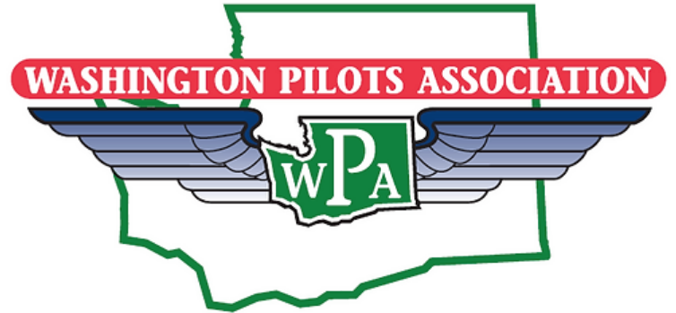

Washington Pilots Association Paine Field Chapter Youth In Aviation Scholarship

The Paine Field Chapter of the Washington Pilots Association is offering one or more $2,000 scholarships for young people in the Washington State area who are pursuing a career in the field of aviation.

Following are the requirements for eligibility:

1. Qualifications for the WPA Paine Field Chapter Youth In Aviation Scholarship Award
a. Young people who are between the ages of 17 and 30, who are pursuing a career in aviation.
b. Applicants must be residents of Washington State.
c. Selection Criteria:
i. Working toward a pilot, A&P, or related certificate
ii. Demonstrates good character in their behavior and community activity.
iii.Demonstrates ability to achieve above average scholastic grades and complete courses requiring self study.
iv. Demonstrates an aptitude for aviation training through successful involvement and/or completion of similar activities.
v. Has demonstrated good discipline to learning, and a cooperative attitude when interacting with others.

2. All applicants must submit an application plus an essay of 300 - 600 words ( 1-2 pages) expressing your passion for and goals related to aviation, your last two years of community involvement and activities, your past and present aviation related activities, financial need, as well as, any additional comments you would like to make to the scholarship committee.

Scholarship application forms are available from your school’s scholarship office, the Washington Pilots Association website, or by contacting WPA Paine Field Chapter Scholarship Committee chairperson Lori Bell at lorileebell@gmail.com

The deadline for all applications is June 30, 2024

